Trade of Sheet Metalwork
Module 4: | General Sheet Metalwork
Unit 1: | Cylinders with Paned-Down Joint
 | Phase 2

Table of Contents
List of Figures 5
List of Tables 6
Document Release History 7
Module 4 – General Sheet Metalwork 8
Unit 1 – Cylinders with Paned-Down Joint 8
Learning Outcome: 8
Key Learning Points: 8
Training Resources: 9
Key Learning Points Code: 9
Peine Joint 11
Percentages & Averages 12
Average 12
Percentage 12
Interconversion with Fractions and Decimals 13
Ratio and Proportion 14
Ratio 14
Proportion 14
Turning Moments and Clamping Force 15
Simple Lever 15
Moment of a Force 16
Example 16
The Law of the Lever 17
To Verify the Law of the Lever 17
Method 18
Example 19
Centre of Gravity 20
Experiment 21
Method 21
Equilibrant of Parallel Forces 22
Example 1 22
Example 2 23
Revision of Average, Ratio, Proportion and Percentage 25
Average 25
Example 25
Ratio 26
Example 1 26
Example 2 26
Example 3 27
Example 4 28
Proportion 29
Example 1 29
Example 2 29
Example 3 29
Solving Proportions 30
Example 4 30
Percentage 32
Example 1 32
Example 2 32
Example 3 33
Example 4 34
Example 5 34
Example 6 34
Example 7 34
Self Assessment 35
Answers to Questions 1-7. Module 4.Unit 1 37
Index 39

List of Figures
Figure 1 - Cylinder with Paned-Down Joint 10
Figure 2 - Pattern for Round Pipe with 8mm Groove Seam with 1mm Metal 11
Figure 3 – Wheelbarrow 15
Figure 4 - Two Spanners 15
Figure 5 - Moment of Force 16
Figure 6 - Law of the Lever 17
Figure 7 - Verify the Law of the Lever 1 18
Figure 8 - Verify the Law of the Lever 2 18
Figure 9 - Equilibrant of Parallel Forces 22
Figure 10 - Wheelbarrow with 400N Load 23
Figure 11 - Three Vertical Forces 24
Figure 12 – Averages 25
Figure 13 – Ratio Example 2 26
Figure 14 - Ratio Example 3 27
Figure 15 – Solving Proportions 30
Figure 16 – Percentage 32

List of Tables

Document Release History
Date | Version | Comments
08/11/06 | First draft
09/01/07 | Implemented edits from Brendan Deasy.
08/04/14 | 2.0 | SOLAS transfer

Module 4 – General Sheet Metalwork

Unit 1 – Cylinders with Paned-Down Joint
Duration – 7 Hours

Learning Outcome:
By the end of this unit each apprentice will be able to:
- Arrange and plan and organise production sequence unassisted
- Develop cylinders with allowance for paned-down and grooved joints
- Notch cylinders
- Cut, roll, groove, swage, stretch, spot weld, jenny up single edge and pane cylinders together
- Blank end/cut, roll, spot weld, jenny up and pane parts together
- Dead end cap

Key Learning Points:
Rk | Notch patterns.
P | Correct sequence of operations.
Sk | Mark patterns directly onto the metal without having to step off divisions.
Sk | Importance of having cylinder round, good stretching, regular flange width, good planishing and proper turn-up allowance for paned joint.
Sk | Even closing of joint.
Sk | Assembly of paned joint without surface marks.
M | Averages, percentages and proportions.
Sc | Centre of gravity.
Sc | Principle of moments/principle of lever.

Training Resources:
- Toolkit
- 0.6 mm mild steel
- Safety equipment and protective clothing
- Tools and machinery/equipment
- Work sample
- Job card
- Book – The Geometry of Sheet Metal Work

Key Learning Points Code:
M = Maths D= Drawing RK = Related Knowledge Sc = Science
P = Personal Skills Sk = Skill H = Hazards

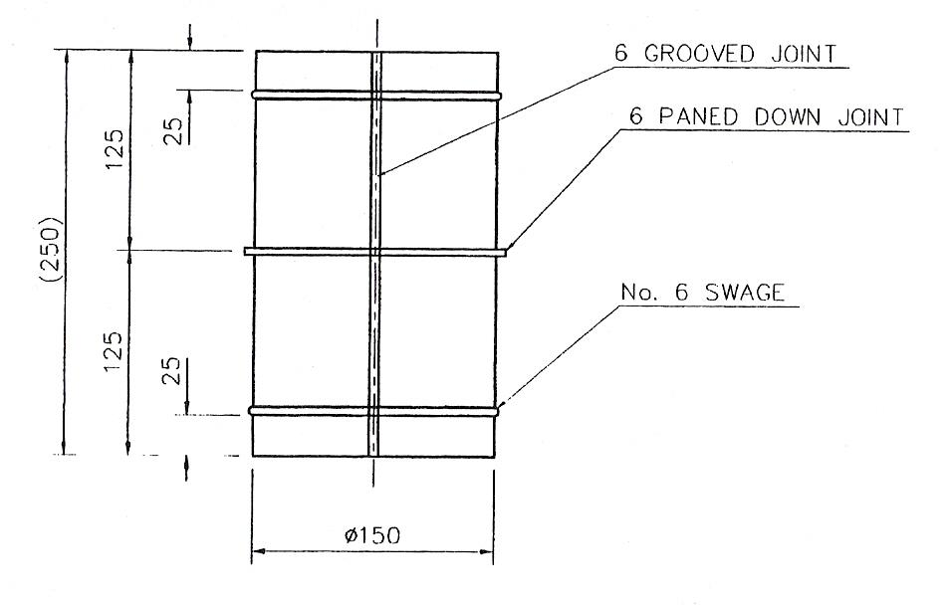
Figure 1 - Cylinder with Paned-Down Joint

Peine Joint
Notching is important to this job. If not enough metal or too much is removed, the point where the peine joint and groove joint intersect will appear unsightly.
As in most jobs there are a variety of ways of doing it.
- If we are to turn up 12 mm for the peine joint we notch on the 15mm line in 8mm and remove the shaded part, on both sides A, B of the circumference. The reason for notching down 15 mm from the edge is to give clearance for the swaging tool. Some sheetmetal workers notch at an angle as shown at C, D. The important point is enough metal is left for a spotweld or braze. This ensures the pipe stays round when stretching the flange.
- The second pipe is notched very similarly. The only change is that the 15 mm becomes 8 mm.
- Next operation is to break the grain of the metal.
- Bend over grooving allowance and pre-set edges. If metal is very light, say 0.6 mm no pre-setting is needed. Put metal in rolls and give a slight kink up with your hands.
- Take care when stretching edge not to have the swaging wheel too tight. Do not attempt to turn too great an angle with swage. 10° - 15° is enough. Stretch the rest by hand.
- The smaller edge 5 mm or 6 mm can be turned over completely using the swaging tool.
- Use a piece of scrap to protect the pipes when closing peine joint with a hammer. Alternatively swaging wheels may be used to close joint.
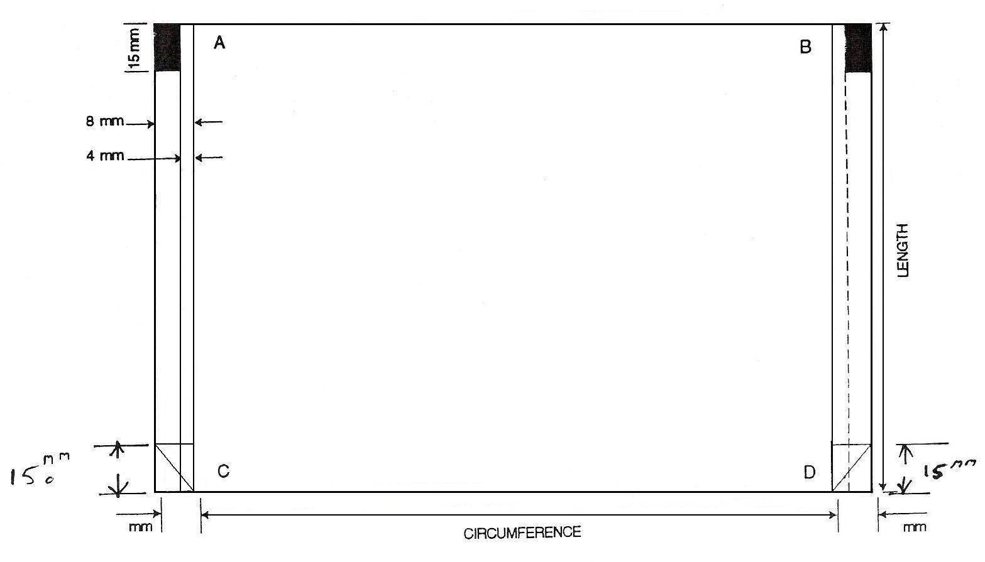
Figure 2 - Pattern for Round Pipe with 8mm Groove Seam with 1mm Metal

Percentages & Averages

Average
An average or mean value of a number of quantities is given by adding the quantities together and dividing by the number of quantities added.
An average is often called the "mean value" or an "arithmetic mean".
Example: Find the average (mean) of 27.3, 17.8, 21.4, 19.7, and 25.1.
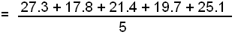
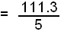
= 22.26 = average (or "arithmetic mean")

Percentage
To write one number as a percentage of another number:
(a) write the numbers as a fraction.
(b) multiply by 100.

Example: Write 36 as a fraction of 300.
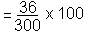

To find a certain percentage of a number:
- find 1% (divide the number by 100)
- multiply your answer by the required percentage.

Example: Find 45% of 260.
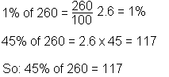

Interconversion with Fractions and Decimals
- To convert a fraction to a percentage (%), simply multiply by 100 and simplify:
Example: 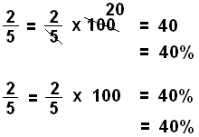
- To change a decimal to a percentage, multiply by 100 by moving the decimal point 2 places to the right:
Example: 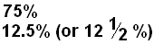

Ratio and Proportion

Ratio
A ratio is a comparison of two quantities. The ratio between two quantities is the quotient obtained by dividing the first quantity by the second. For example, the ratio between 3 and 12 is ¼, and the ratio between 12 and 3 is 4. Ratio is generally indicated by the sign (:), thus 12:3 indicates the ratio of 12 to 3.
A Reciprocal or Inverse ratio is the opposite of the original ratio. Thus, the inverse ratio of 5:7 is 7:5.
In a Compound ratio, each term is the product of the corresponding terms in two or more simple ratios. Thus, when:
8:2 = 4; 9:3 = 3; 10:5 = 2
then the compound ratio is:
8 x 9 x 10:2 x 3 x 5 = 4 x 3 x 2
720:30 = 24
Note: all ratios can be expressed as fractions for use in calculations.
Example: 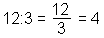

Proportion
Proportion is the equality of ratios. Thus:
6:3 = 10:5, or 6:3 :: 10:5
:: symbol means ‘as’
The first and last terms in a proportion are called the extremes; the second and third, the means. The product of the extremes is equal to the product of the means. Thus:
25:2 = 100:8 and 25 x 8 = 2 x 100

Turning Moments and Clamping Force

Simple Lever
A lever is a rigid body which is free to turn about a fixed point called the fulcrum. The wheelbarrow shown in the figure below may be considered a lever. The force applied to the handles is called the effort while the force exerted by the mass is known as the load. The axle is the fulcrum.
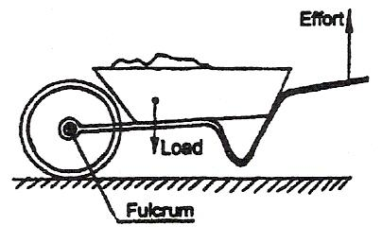
Figure 3 – Wheelbarrow

A spanner may also be considered a lever. The sketches below show two spanners used to loosen a tight nut. The nut cannot be loosened by the left hand spanner while that on the right is successful in loosening the nut by the application of the same force at a greater distance from the fulcrum.
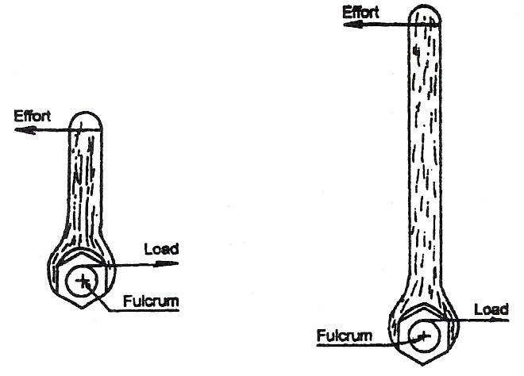
Figure 4 - Two Spanners

Moment of a Force
The turning effect of a force is called the moment of the force. The moment of the force = force x perpendicular distance from the fulcrum to the line of action of the force.

Example
A crowbar is used to life a machine as shown in the sketch below. Calculate the moment of the force being applied.
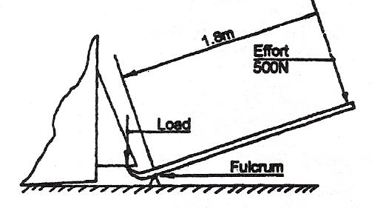
Figure 5 - Moment of Force

Solution:
Moment = force x distance
= 500 x 1.8
= 900 Newton-metre
Moment = 900 Newton-metre, (written Nm for short).
=900 Nm

The Law of the Lever
The see-saw shown below (Figure 6) is perfectly balanced even though the man's weight is greater than the child's weight. However, the man is nearer to the fulcrum than the child and the moments of the weight on each side are equal.
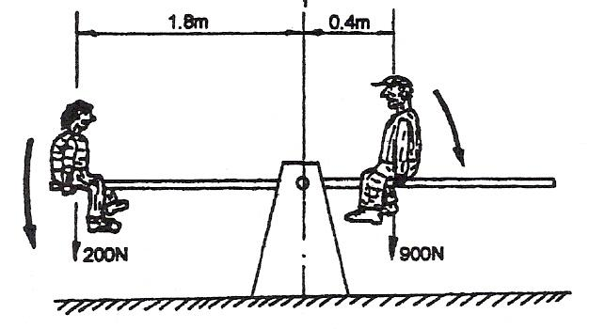
Figure 6 - Law of the Lever

The man exerts a clockwise moment while the child exerts an anti-clockwise moment. When a lever is balanced, the sum of the clockwise moments acting on it is equal to the sum of the anti-clockwise moments. So as the see-saw (or lever) is balance, it follows that 200 x 1.8 (anti-clockwise moments) is equal to 900 x 0.4 (clockwise moments).

To Verify the Law of the Lever
You will require the following; metre stick, stand or support, string, different known weights (e.g. 1N, 2N, etc. or approximations 0.1 kg, 0.2 kg masses).

Method
- Hang the metre stick from the stand or support.
- Adjust the position of the string until the metre stick is balanced. The point from which it now hangs is the fulcrum.
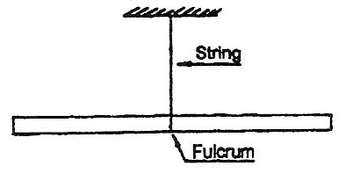
Figure 7 - Verify the Law of the Lever 1

- Hang a 1N weight on the left hand side of the metre stick and a 2N weight on the other side as shown in FIG. Adjust the position of these weights until the lever is balanced.
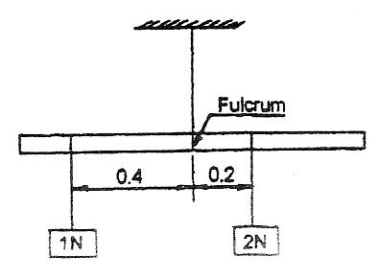
Figure 8 - Verify the Law of the Lever 2

- Calculate the moment of the weight on each side and record it in the table below.
Anti-clockwise moment | 1 x 0.4
Anti-clockwise moment | = 0.4
Clockwise moment | 2 x 0.2
Clockwise moment | = 0.4

- Repeat the experiment several times with the same weights in different positions.
- Record each moment in the table shown above. You should find that the clockwise moment is equal to the anti-clockwise moment each time.

Example
A metre stick is balanced when suspended at the 500 mm mark. A weight of 10N is hung from the 290 mm mark. This is balanced by an unknown weight 'W' hanging at the 850 mm mark. Find the unknown weight.

Solution:
Distance between 10N weight and fulcrum
= 500 - 290
= 210 mm = 0.21 m

Distance between unknown weight and fulcrum
= 850 - 500
= 350 mm = 0.35 m

Anti-clockwise moment
=10 x 0.21 = 2.1 Nm

Clockwise moment
= W x 0.35 = 0.35 W Nm

Anti-clockwise moment = Clockwise moment
W x 0.35 = 10 x 0.21
W = 2.1/0.35
= 6 N
Unknown weight = 6 N

Centre of Gravity
The centre of gravity of an object is the point through which all the weight of an object appears to act. In the experiments of lever, when the metre stick is balance, the force of gravity is still acting on it. The metre stick is suspended at its centre of gravity.

Test Yourself
This figure shows a person carrying a ladder. Suggest a more suitable position along the ladder for him to carry it.
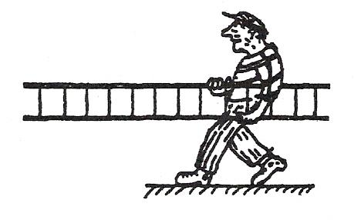

Answer:
It would be much easier to carry the ladder by supporting it at its centre of gravity.

Experiment
Find the weight of an object such as a spanner using one known weight and a piece of string.

Method
- Find the centre of gravity of the spanner by balancing as shown in sketch.
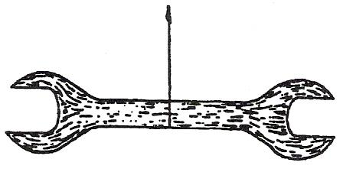
- Mark position of the centre of gravity on spanner.
- Move the point of suspension to the left or right of centre of gravity.
- Use known weight to balance spanner as shown.
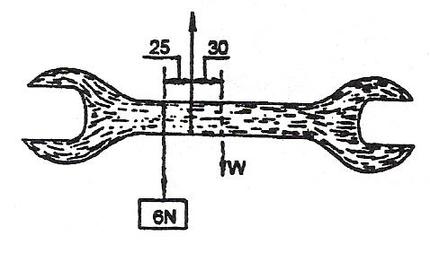
- Assuming weight and distances are as recorded on sketch, the weight of the spanner may be found as follows.
Clockwise moments = Anti-clockwise moments
W x 30 mm = 6N x 25 mm
W = 6 x 25/30
= 5N
Weight of spanner = 5N
Mass of spanner = 0.5kg (1kg = 10N)

Equilibrant of Parallel Forces
In the experiment on the lever, one upward force at fulcrum balanced the two downward forces and the weight of the metre stick. The term equilibrant is used to denote a force which balances a number of other forces.

Example 1
The figure below shows a metre stick suspended at its centre of gravity and supporting three weight. If the weight of the metre stick is 1.5N, calculate the upward force at the fulcrum.
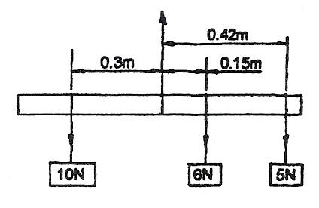
Figure 9 - Equilibrant of Parallel Forces

Solution:
Total weight = 10 + 6 + 5 + weight of metre stick
= 10 + 6 + 5 + 1.5 = 22.5N

Upward force = total downward force = 22.5N

Example 2
Figure 10 shows the outline of a Wheelbarrow with a load of 400N, calculate the effort necessary to lift the wheelbarrow and the force exerted on the axle when the wheelbarrow is raised.
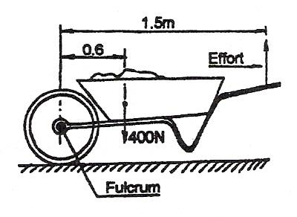
Figure 10 - Wheelbarrow with 400N Load

Solution:
The axle is the fulcrum, taking moments about the axle (fulcrum).
Clockwise moments = Anti-clockwise moments
400N x 0.6m = effort x 1.5m
- = E x 1.5
240/1.5 = E
E = 160N
EFFORT = 160N

Load on axle
The three vertical forces are as shown.
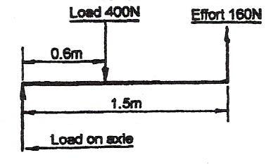
Figure 11 - Three Vertical Forces

Total downward force = 400N
Total upward force = 160N (effort) + load on axle
Total upward force = 400N
160N + load on axle = 400N
Load on axle = 400 – 160
Load on axle = 240N

Test Yourself
Refer to sketch of the wheelbarrow (Figure 11) and consider the following. Where the load is moved forward towards the axle (fulcrum):
- Would the effort (a) increase, (b) decrease or (c) remain as calculated at 160 N.
- Would the load on the axle (a) increase, (b) decrease or (c) remain as calculated at 240N.
- Is the load on the axle (fulcrum) an action or reaction force.

Answer:
- The effort would decrease, since the moment of the load about the axle decreases.
- The axle load would increase, since the load is nearer the axle.
- The load on the axle is a reaction to the 400N load in the barrow.

Revision of Average, Ratio, Proportion and Percentage

Average
The average or mean of a group of numbers is the number which is generally the most representative of all the numbers in the group. The mean height of the four craftsmen shown below, whose individual heights are 1.95m, 1.75m, 1.6m and 1.42m, may be found as follows:
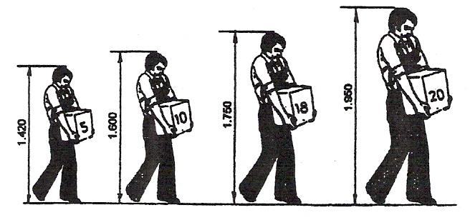
Figure 12 – Averages

First add the four heights:
1.95m + 1.75m + 1.6m + 1.42m = 6.72m

Now divide the total by four since there are four individuals in the group.
Average Height = 6.72/4 = 1.68m

Example
Refer to previous sketch and determine the average mass carried by a craftsman.

Test Yourself
From a batch of steel pins, five are chosen and their diameters found to be 14.95, 15, 15.02, 14.98 and 15.04 mm. Find the average diameter.

Answer:
Average diameter
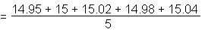
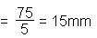

Ratio
A fraction can have three meanings:
- A fraction can name a certain number of parts of a whole.
3/8 names three parts of a whole which has been divided into eight parts.
- A fraction may indicate division
3/8 can be thought of as 3 + 8
- A fraction can be a ratio. A ratio is a means of comparing two numbers or quantities.

Example 1
To compare 3 to 8 we write the ratio 3 to 8 as 3/8, or 3:8 = 3/8.

Example 2
Refer to the sketch of the rectangle. The ratio of its width to its length is 14 mm to 39 mm (14:39).
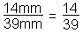

You compare mm to mm, so the units cancel.
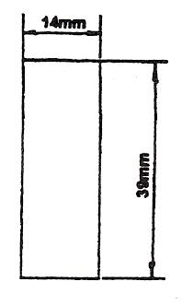
Figure 13 – Ratio Example 2

The ratio of its length to its width is:
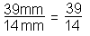

Note: The ratio is always left as a fraction or in the form 39:14.
Since a ratio is a fraction, we can reduce a ratio to its lowest terms.

Example 3
Refer to the sketch of a cylinder. The ratio of its diameter to its height is 30 mm to 50 mm.
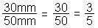
(Divide numerator and denominator by the common factor 10)
Diameter: Height = 3:5
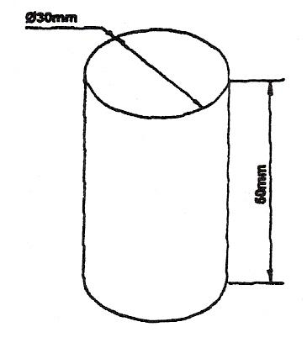
Figure 14 - Ratio Example 3

Test Yourself
Express the following ratios in their lowest terms:
- 200mm to 1.2m (200mm:1.2m)
- 3in to 1ft (3in:1ft)
- 500g to 1.2kg (500g:1.2kg)
- 160ml to 1 litre (160ml:1l)

Answer:
- 200/1200 = 1/6 (1:6)
- 3/12 = 1/4 (1:4)
- 500/1200 = 5/12 (5:12)
- 160/1000 = 4/25 (4:25)

Cutting fluids use soluble oil in the ratio of approximately one part soluble oil to twenty parts water. The ratio of soluble oil to water is 1 to 20 (1:20). If we add the one part soluble oil to twenty parts water, we have twenty one parts in total. The amount of soluble oil which makes up the cutting fluid is 1/21 of the total, while the amount of water is 20/21 of the total.

Example 4
The composition of brass is in the ratio two parts zinc to three parts copper, determine the mass of zinc and mass of copper necessary to make up (1 tonne) 1,000 kg of brass.
Total number of parts: 2 + 3 = 5
2/5 = zinc
3/5 = copper
Mass of zinc 2/5 x 1,000 = 400 kg
Mass of copper 3/5 x 1,000 = 600 kg

Check
Total mass of zinc and copper
= 400 kg + 600 kg = 1,000 kg
Ratios can apply to more than two quantities. When mixing materials for a concrete floor, the ratio of sand to gravel to cement is 2 to 5 to 1 (2:5:1) that is two parts of sand to five parts of gravel to one part cement by volume. The volume of the Individual parts In one cubic metre of the mix is found as follows:
Total number of parts = 2 + 5 + 1 = 8 parts
2/8 = 1/4 = sand in mix
5/8 = gravel in mix
1/8 = cement in mix

Test Yourself

The sides of the triangle are in the ratio 3 to 4 to 5 (3:4:5). If the perimeter (length all around) of the triangle is 192mm, what is the length of each side?
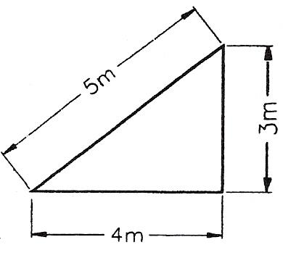

Answer:
Total number of parts 3 + 4 + 5 = 12
Longest side = 5/12 of 192 = 5/12 x 192 = 80mm
Shortest side = 3/12 of 192 = 3/12 x 192 = 48mm
Intermediate side = 4/12 of 192 = 4/12 x 192 = 64mm
Total = 192 mm

Proportion
There is a very close connection between ratio and proportion. A statement that two ratios are equal is called a proportion.

Example 1
Since the ratio 3 to 8 (3:8) is equal to the ratio 6 to 16 (6:16), we can write the proportion.
3/8 = 6/16
We read the proportion 3/8 = 6/16 as 3 is to 8 as 6 is to 16.
This statement may also be written as follows:
3:8 :: 6:16 :: This symbol means 'as'
Working with two equal ratios, i.e. a proportion can be very useful in the solution of certain types of problems.

Example 2
During a turning operation, 40g of metal is removed in 8 minutes. How much metal will be removed in 12 minutes?

Answer:
Express both relationships as ratio 40g is to 8 minutes as unknown is to 12 minutes
40/8 = unknown/12
from observation, the unknown quantity is 60 g of metal.
Since 40/8 = 60/12 = 5
A useful property holds for the terms of a true proportion.

Example 3
3/8 = 9/24
The product of 8 x 9 (72), is equal to the product 3 x 24 (72). This is sometimes called cross multiplication.
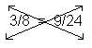
8 x 9 = 3 x 24

Solving Proportions
In solving problems associated with proportion usually one of the four terms is missing or unknown. If three of the four terms are known, one can always find the missing or unknown term.
Consider Example 2 above:
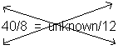
Cross multiply 8 x unknown = 40 x 12
One important property of an equation is that we can divide both sides by the same non-zero number, here we divide by 8.
8 x unknown/8 = 40 x 12/8
Unknown = 40 x 12/8 = 60
60 g is the answer to Example 2 above.

Example 4
Sketch shows two gear wheels in mesh. The diameter of A is 100 mm while the diameter of B is 20 mm. How many gear teeth are on A if B has 8 teeth?
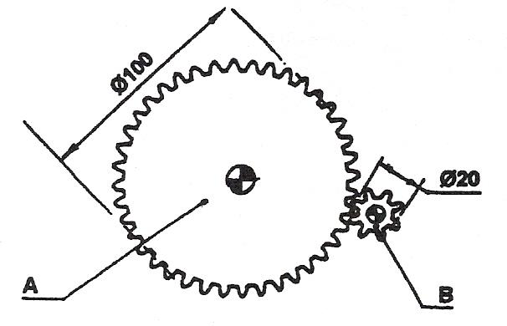
Figure 15 – Solving Proportions

Express both relationships as ratios.
8/20 = unknown/100
Cross multiply: unknown x 20 = 8 x 100
Unknown = 8 x 100/20 = 40 teeth
Test Yourself
The sides of the triangle shown are in the ratio 5 to 12 to 13 (5:12:13).
If the length of the longest side is 104 mm, what is the length of the horizontal side and vertical side?
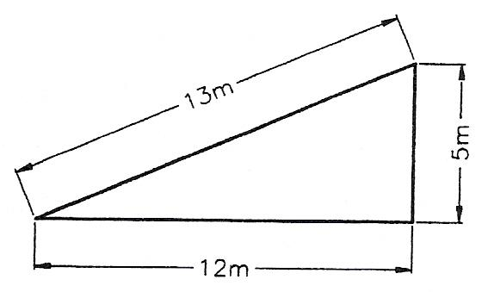

Answer:
Express relationship as ratios
104/13 = vertical/5 : 104/13 = horizontal/12
Cross multiply
13 x vertical = 5 x 104
vertical = 5 x 104/13 = 40 mm
13 x horizontal = 12 x 104
horizontal = 12 x 104/13 = 96 mm

While the three sides of the triangle are in the ratio 5:12:13, the true lengths of the three sides are 40 mm, 96 mm and 104 mm.

Percentage
In considering parts of a whole or unit, we have used fractions and decimals. The idea of percentage is another way of naming parts of a whole. We may think of percent as ratio whose denominator is 100.
We could say that:
- 1/4 of the sketch is shaded,
- 0.25 of the sketch is shaded,
- 25 percent of the sketch is shaded.
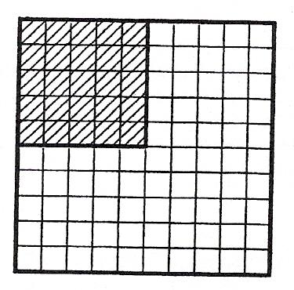
Figure 16 – Percentage

The word percent means hundredths. 25/100 is the same as 25 percent which is usually written 25%.
We use the symbol % for percent.

Example 1
12 out of a total of 25 applicants were accepted for employment.
12/25 = 48/100 to obtain a denominator of 100, multiply top and bottom by 4.
48% of applicants were accepted.

Changing a fraction to a percent
Multiply the fraction by 100 and attach the % sign.

Example 2
- Write 3/5 as a percent.
To write 3/5 as a percent we multiply by 100.
3/5 x 100 = 60%.
- Write 1/6 as a percent.
1/6 x 100 = 16.666.
= 16.7% to the nearest first decimal place.

Example 3
Bronze used for bearings consists of 1 part tin to 4 parts lead to 15 parts copper. Express these as percentages.

Answer:
Total numbers of parts 1 + 4 + 15 = 20
% tin = 1/20 x 100 = 5%
% lead = 4/20 x 100 = 20%
% copper = 15/20 x 100 = 75%

Bearing bronze consists of 5% tin, 20% lead and 75% copper.

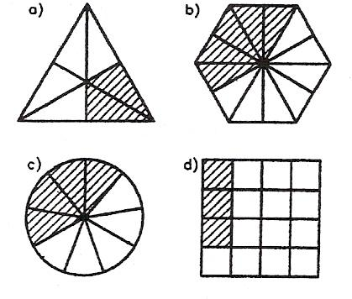
Test Yourself
- Use percentages to name the shaded area of each diagram.
- Use percentages to name the unshaded area of each diagram.

Answer:
Shaded Area
- 1/3 = 1/3 x 100 = 33.3%
- 5/12 = 5/12 x 100 = 41.7%
- 4/9 = 4/9 x 100 = 44.4%
- 3/16 = 3/16 x 100 = 18.75%

Unshaded Area
- 2/3 = 2/3 x 100 = 66.7%
- 7/12 = 7/12 x 100 = 58.3%
- 5/9 = 5/9 x 100 = 55.6%
- 13/16 = 13/16 x 100 = 81.25%

Changing a percent to fraction
Remove the percent sign and write the number over 100.

Example 4
12% = 12/100 = 3/25

Example 5
160% = 160/100 = 1 60/100 = 1 3/5

Changing a percent to a decimal
Remove the percent sign and move the decimal point two places to the left.

Example 6
- 25% = 0.25 The decimal point is thought of as after the 5.
- 9% = 0.09 We must add a zero to move the decimal point.
- 125% = 1.25 A percent greater than 100 gives a decimal greater than 1.

Changing a decimal to percent
Move the decimal point two places to the right and attach the percent sign.

Example 7
- 0.33 = 33% Move decimal point two places to the right.
- 0.05 = 5%.
- 1.25 = 125%.

Test Yourself
- What is 3% of 10.25mm?
- An error of 5% is made in a measurement of 9/16 in, estimate the error in mm. (25.4 mm=1 in)

Answer:
- 3% = 0.03 0.03 x 10.25 = 0.3075
- 9/16 in = 9/16 x 25.4 = 14.2875
5% = 0.05
Error = 0.05 x 14.2875 = 0.714375 mm
= 0.71 mm

Self Assessment
Questions on Background Notes – Module 4.Unit 1

1. Sometimes it’s not necessary to pre-set edges, why is this so?

2. Write 18 as a fraction of 150.

3. What is the definition of a lever?

4. Explain the movement of a force.

5. When is a lever in equilibrium?

6. How do you change a fraction to a percentage?

7. How do you change a decimal to a percent?

Answers to Questions 1-7. Module 4.Unit 1
1.

If the metal is very light, say 0.6mm no pre-setting is needed.
2.

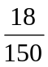 = 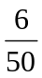 = 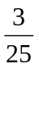 answer

3.

A lever is a rigid body free to rotate about a fixed point called
the fulcrum.

4.

The turning affect of a force is called the moment of force.

The moment of force = Force x perpendicular distance from the fulcrum
to the line of action of the force.

5.

When the sum of the clockwise moments equals the sum of the
anticlockwise moments.

6.

Multiply the fraction by 100 and attach the % sign:

e.g. 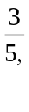 x 100 = x 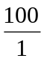 = 5 100 = 20, 3 x 20 = 60%

7.

Move the decimal place two points to the right and attach
the % sign.

e.g. 0.33 = 33%
0.05 = 5%
1.25 = 125%

Index

A
Average
Example, 25
C
Centre of Gravity
Equilibrant of Parallel Forces, 22
Example 1, 22
Example 2, 23
Experiment, 21
Method, 21
P
Peine Joint, 11
Percentage
Example 1, 32
Example 2, 32
Example 3, 33
Example 4, 34
Example 5, 34
Example 6, 34
Example 7, 34
Percentages & Averages, 12
Average, 12
Interconversion with Fractions and Decimals, 13
Percentage, 12
Proportion
Example 1, 29
Example 2, 29
Example 3, 29
Example 4, 30
Solving Proportions, 30
R
Ratio
Example 1, 26
Example 2, 26
Example 3, 27
Example 4, 28
Ratio and Proportion, 14
Proportion, 14
Ratio, 14
Revision of Average, Ratio, Proportion and Percentage, 25
Average, 25
Percentage, 32
Proportion, 29
Ratio, 26
S
Simple Lever
Example, 16
Moment of a Force, 16
T
The Law of the Lever
Example, 19
Method, 18
To Verify the Law of the Lever, 17
Turning Moments and Clamping Force, 15
Centre of Gravity, 20
Simple Lever, 15
The Law of the Lever, 17

